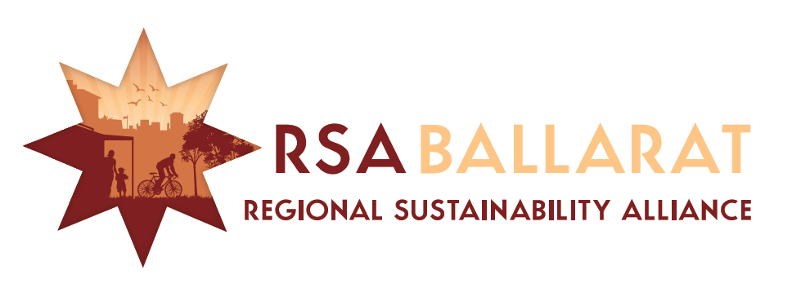
Coordination Group
Meeting – MINUTES

1.00pm Tuesday 24th February 2015 at State Government Offices cnr. Mair and Doveton Streets Ballarat

Chair: Ian Rossiter (BREAZE) Minutes: Ian Rossiter (BREAZE)

Agenda Items | Discussion | Responsibility
- Welcome/ Apologies/ Introductions | Attendance: Trish Kevin (Sustainability Victoria), Cr Belinda Coates (City of Ballarat), Craig Hurley (Fed Uni), Lauren Burch (City of Ballarat), , Ian Rossiter (BREAZE). Lisa Kendal (Cultivate Agribusiness CH), Ray and Cherie Draper (BEN), Dave Watson (DELWP) Quenton Gay (City of Ballarat),  Apologies:  John Kilgour (Committee for Ballarat), Cherie Draper (BEN), Hazen Cleary, Laurel Freeland (Fed Uni) Brendan Clarke (CHW).
- Minutes of Previous Meeting | Minutes of Meeting held XXX December 2014 were adopted. Moved XX, seconded XX.
- Living Ballarat Project Update | Quenton briefed the meeting on the City of Ballarat Green Infrastructure Strategy being undertaken by E2 Design Lab under the leadership of Dr Peter Breen. The consultants will be working to deliver the draft by September 2015. Strategy to identify opportunities and policy for storm water management, harvesting and Urban forestry approach to managing our urban landscape.  The Stormwater and Urban Flooding Task Group reports to a steering group with representation from DELWP, CHW and BCC.  DELWP’s Land and Water Division is developing templates for Whole of Water Cycle Management Plans  Central Highlands Water is preparing the Ballarat System Whole of Water Cycle Management Strategy. There will be engagement activities over next 2 months.
- Cultivate Agribusiness Central Highlands Update | Lisa Kendal (Executive Officer) explained that (Central Highlands Agribusiness Forum was now renamed) Cultivate Agribusiness Central Highlands is delivering a number of regional programs and projects across Moorabool, Hepburn, Ararat, Ballarat and Pyrenees local government areas.  CACH are also supporting SEAM (Sustainable Environment Artists Movement) to deliver a performing arts event at the Earth Ed Centre in Mt Clear in May.
- MOU between City of Ballarat and RSAB | Ian reported on the obligations required by the MOU between City of Ballarat and RSAB and led discussion on what eventuated and whether expectation shave been met. RSAB provided the required feedback on implementation of the Council’s Environment Strategy, The annual report environmental scorecard and feedback on the Draft Ballarat Strategy.  The rationale for the agreement was discussed which related to a proposal by City of Ballarat to establish an Environment Sustainability Advisoory Committee and the consideration that RSAB could provide the required input and feedback to Council’s processes.  Discussion led to a conclusion that the $5,000 consideration could have achieved more in terms of bringing groups together and building consensus on key environmental issues.  The action agreed was that the Chair should provide a report to the City of Ballarat and RSAB on what has been achieved under the MOU and a proposal for its extension with an obligation to provide forums to bring environmental groups and issues together that are relevant to the City of Ballarat and RSAB membership. | ian
- RSAB Activities and Roles for 2015 | The group first explored expanding membership. It was suggested the following be approached to participate:  - Central Victorian Greenhouse Alliance – suggest Sebastian Klein be approached as member.  - Grampians Central West Waste and Resource Recovery Group – Invite Philip Clingin Executive Officer to participate.  - Golden Plains Shire – Invite Dale Smithyman to participate (Environment Officer)  - Peter Gell – Professor Environmental Management Federation University  The membership is keen for RSAB to run several forums and / or workshops in 2015 that will bring together members to commit to shared projects, issue resolution or communications.  Suggestion from Lisa that we approach David Kendal to include “Citizen Science” assessment of new developments.  Suggestion that we publish a 6 monthly publication and time the releases with key decision making calendars of state and local government.  The concept of a members’ newsletter was discussed and it was concluded that it would be reliant on members contributing to enhance information sharing.  A facebook page may be more effective than the redundant webpage. | Ian  All
- Information Sharing | - Ballarat Environment Network – Ray reported that BEN is undergoing some structural changes and is still committed to participating in RSAB  - City of Ballarat – Lauren reported that with a Sustainability Victoria Grant a mattress recycling facility is being established at Gillies Street Transfer Station. Council is developing an Integrated Waste Management Prospectus in order to go to market to seek submissions. The Environment Sustainability Strategy and State of the Environment report will be presented to Council in coming months.  - CVGA – Belinda reported that CVGA’s bulk purchase for community facilities project is underway (PV’s and SHW) and a heat Stress project through Health and Community Care (HACC) funding program.  - Victorian Adaptation and Sustainability Partnership (VASP) has funded a land Use Systems and Modelling and Mapping with Climate Change in our region.  - BREAZE has applied to Acciona Energy for a community grant to acquire a zero emissions electricity supply trailer unit which can be used for events. The $10K grant with BREAZE’s in kind would provide a biodiesel generator, battery supply and PV panel recharge facility for community events. | All to note
- 2015 Meetings | Discussion and feedback on the time and day of meetings indicates that Tuesday Afternoons suit most parties with adequate prior notice.  Could members advise if the following proposed schedule of meetings suits:  - Tuesday 21 April 2015  - Tuesday 16 June 2015  - Tuesday 18 August 2015  - Tuesday 20 October 2015

